**Midterm Test (Written Part)**

This test is opened book. You have 1 hour to complete this test. You are allowed to use the computer and other resources for this test.

This test is worth 40% of your grade.

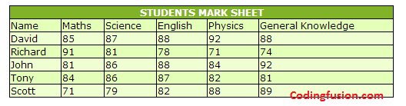

* Create the above table in HTML **[10 marks]**
* Configure the table using the altrow class or the first-of-type structural pseudo-classes (odd class, even class, e.t.c). **[10 marks]**
* Use the colomn span for the first row. **[10 marks]**
* Upload your file to the MidTerm drop box. **[10 marks]**

NOTE: You can use any color of your choice do not add the codingfusion.com text to it.